California State University Fullerton

CPSC 462



Object Oriented Software Design

Use Case Model

for the



Hotel Reservation

System

|  |  |  |
| --- | --- | --- |
|  | **Josh Ibad** |  |
|  | [Chief Software Architect](mailto:joshcibad@csu.fullerton.edu?subject=Regarding the HotelBuch System) |  |
|  | [joshcibad@csu.fullerton.edu](mailto:joshcibad@csu.fullerton.edu?subject=Regarding the HotelBuch System) |  |

Revision History:

| Version | Date | Summary of Changes | Author |
| --- | --- | --- | --- |
| 1.0 | 2021-10-18 | * Initial Release | Josh Ibad |
| 2.0 | 2021-11-15 | * Changed role to Chief Software Architect * After careful review of management and another reviewal of the design team, no further revisions were found necessary. The use case diagram is sufficient and reflective of the system at the current iteration, and the Use Case descriptions remain sufficient and is the same as the last iteration. * Will be reviewed again in subsequent iterations. | Josh Ibad |

**Table of Contents**

1 Use Case Diagram 2

2 Use Case Brief Descriptions 3

2.1 Manage Hotel Room Listing 3

2.2 Manage Guest Accommodation 3

2.3 Manage Reservations 3

# Use Case Diagram

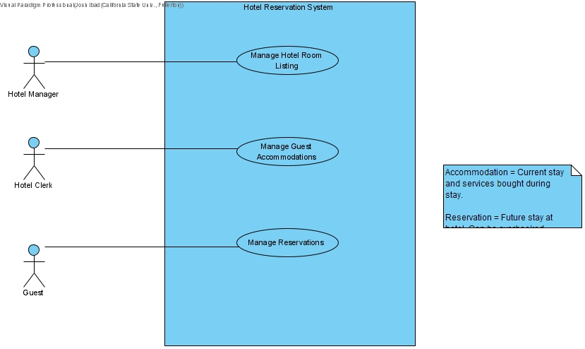

Figure 1.1 - **Hotel Reservation System Use Case Diagram**: Three primary actors are shown to use the Hotel Reservation System. The Hotel Manager manages hotel rooms through the Hotel Reservation System. The Hotel Clerk manages guest accommodations which includes the actions of managing reservations. Finally, the Guest manages their own reservation on the Hotel Reservation System.

# Use Case Brief Descriptions

## Manage Hotel Room Listing

Hotel Manager requests a list of hotel rooms registered. The system responds with its list of hotel rooms. Then, the manager requests to add a hotel room, providing information regarding the room. The system responds with a receipt of the tasks's success or failure.

## Manage Guest Accommodation

Hotel Clerk requests a list of hotel rooms. The system responds with a list of hotel rooms, along with current reservation and accomodation info. Then, the Hotel Clerk requests to register guest accomodation, providing the time of guest check-in. The system responds with a receipt of the accomodation tasks's success or failure. Finally, the Hotel Clerk requests to register a priced service to the guest's running balance, providing service type and possibly quantity. The system responds with a receipt of the transaction's success or failure.

## Manage Reservations

Guest requests a list of available rooms providing a specified date range for the reservation. The system responds with a list of rooms available at the specified date range along with basic details such as price, capacity, and features. Then, the Guest requests to begin reserving the room. The system responds with more info about the room as well as payment info. Finally, the Guest requests to finalize the reservation, providing personal information and billing info. The system responds with a confirmation of reservation and a receipt of transaction.